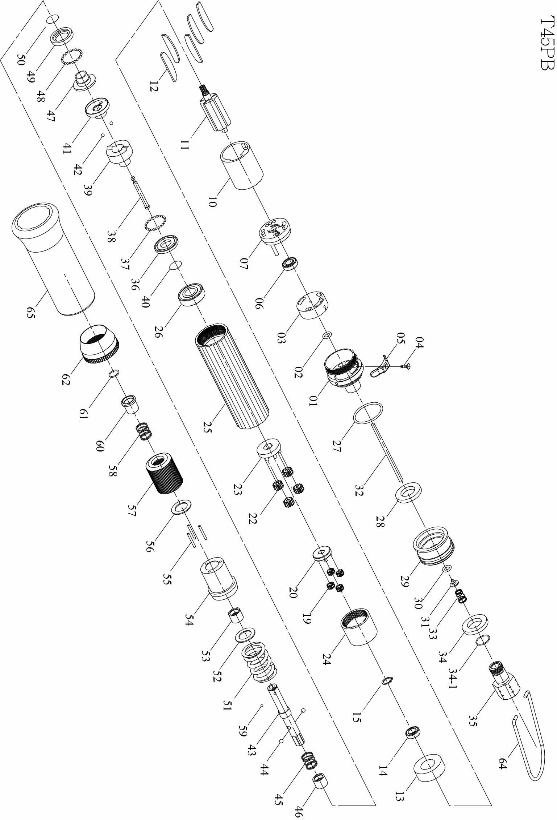

No. | Part No. | Part Name | Q’ty | No. | Part No. | Part Name | Q’ty
1 | 5A3004 | End Housing (Blue) | 1 | 36 | 2S2103 | Retainer | 1
2 | 7Q2005 | O Ring | 1 | 37 | 7S2102 | Ball | 28
3 | 2P3000 | Valve | 1 | 38 | 3S2001 | Pilot Pin | 1
4 | 7S2158 | Set Screw And Washer | 1 | 39 | 3S2211 | Rear Clutch | 1
5 | 2L3010 | Switch | 1 | 40 | 6N2006 | C Ring | 1
6 | 7S2016 | Ball Bearing | 1 | 41 | 3S2215 | Center Clutch | 1
7 | 1S3001 | End Plate | 1 | 42 | 7S2112 | Ball | 2
10 | 1P3005 | Cylinder | 1 | 43 | 3S2021 | Anvil | 1
11 | 1S3041 | Rotor | 1 | 44 | 7S2105 | Ball | 2
12 | 1P3050 | Blade | 5 | 45 | 6N2110 | Spring | 1
13 | 1P3060 | Front Plate | 1 | 46 | 3S2226 | Slide Base | 1
14 | 7S2002 | Ball Bearing | 1 | 47 | 3S2222 | End Clutch | 1
15 | 6N2020 | C Ring | 1 | 48 | 7S2102 | Ball | 22
19 | 1P2120 | 15T Plant Gear | 4 | 49 | 3S2231 | Ball Race | 1
20 | 1P2283 | Fifth Gear Cage | 1 | 50 | 6N3100 | C Ring | 1
22 | 1P2121 | 15T Plant Gear | 4 | 51 | 6N3005 | Torque Spring | 1
23 | 1P2286 | Fifth Gear Cage | 1 | 52 | 2S2120 | Washer | 1
24 | 1S2061 | Internal Gear | 1 | 53 | 3S2245 | Anvil Bushing | 1
25 | 5A3010 | Center Housing (Blue) | 1 | 54 | 3A2203 | Clutch Housing | 1
26 | 7S5003 | Ball Bearing | 1 | 55 | 6S2011 | Needle Pin | 3
27 | 7Q2015 | O Ring | 1 | 56 | 3S3101 | Regulation Washer | 1
28 | 2P3010 | Silencer | 2 | 57 | 3A3001 | Torque Ring | 1
29 | 2A3001 | Exhaust Deflector | 1 | 58 | 6N2110 | Spring | 1
30 | 7Q2007 | O Ring | 1 | 59 | 7S3107 | Ball | 1
31 | 6S2020 | Valve Plate | 1 | 60 | 5S2001 | Bit Slide Sleeve | 1
32 | 6S2009 | Operating Rod | 1 | 61 | 6N2001 | C Ring | 1
33 | 6N2101 | Cone Spring | 1 | 62 | 5A3020 | Rear Housing | 1
34 | 2P3020 | Silencer | 1 | 64 | 5N2001 | Suspension Ring | 1
34-1 | 2Q5001 | O Ring | 1 | 65 | 5L3010 | Soft Cover | 1
35 | 2S2002 | Air Inlet Bushing [PT] | 1

